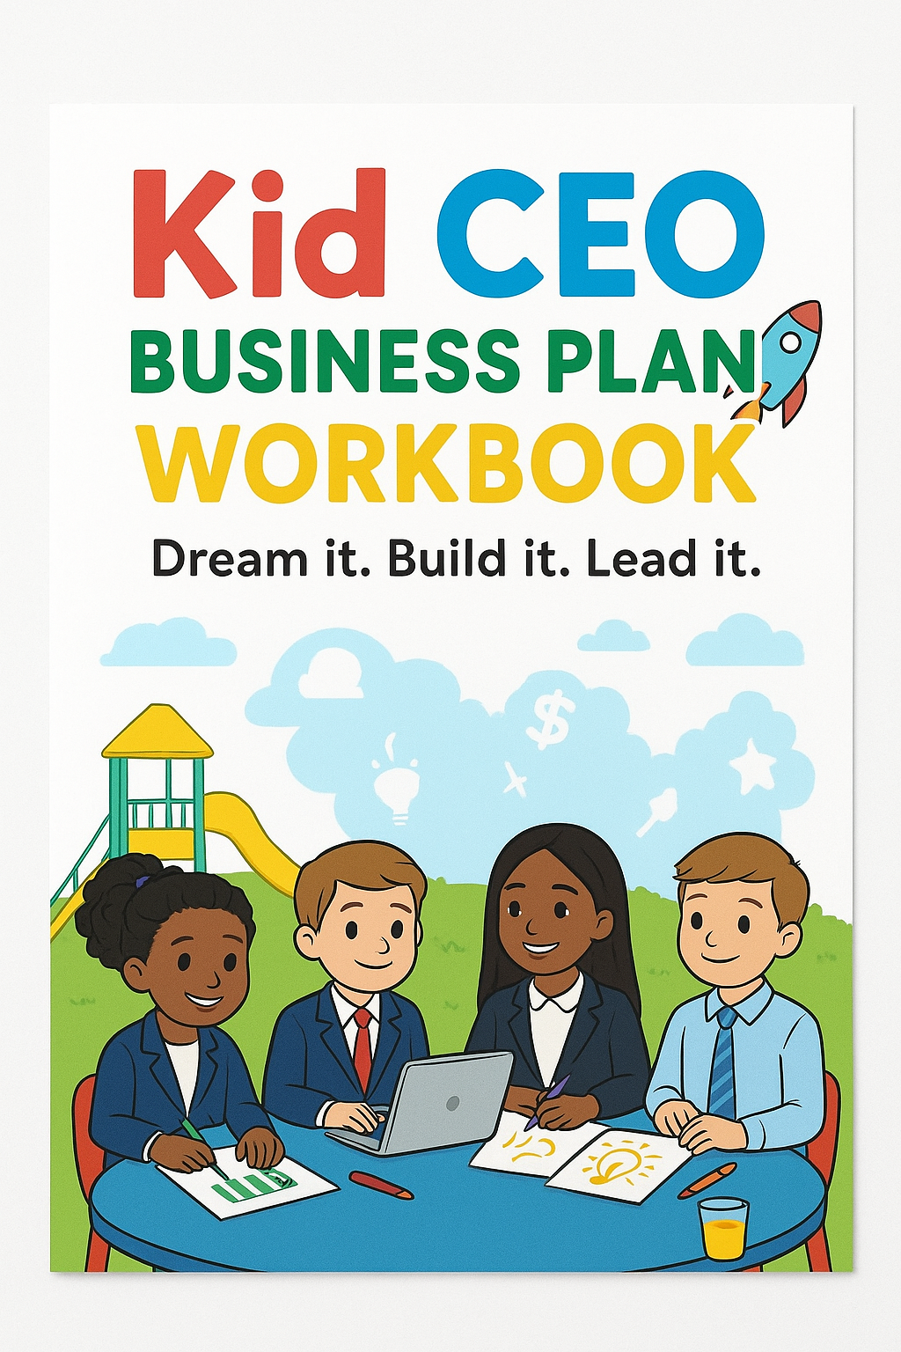



Hello! I’m a CEO
This is my Business Plan

My Name is: __________________________________

🚀 Kid CEO Business Plan
For Young Entrepreneurs
Dream it. Build it. Sell it. Lead it!

1. 📝 My Business Name
👉 What’s the name of your business?
(Tip: Make it fun, catchy, and easy to remember!)
Example: Maya’s Magical Slimes
---------------------------------------------------------------------------------------------------------------------
---------------------------------------------------------------------------------------------------------------------
---------------------------------------------------------------------------------------------------------------------

2. 🎨 My Big Idea
👉 What are you selling or offering?
Example: Handmade slime kits with glitter, scents, and cool packaging
---------------------------------------------------------------------------------------------------------------------
---------------------------------------------------------------------------------------------------------------------
---------------------------------------------------------------------------------------------------------------------
---------------------------------------------------------------------------------------------------------------------

3. 🎯 My Customers
👉 Who will buy your product or service?
Examples:
- Kids ages 6–12 who love slime
- Parents shopping for birthday gifts
- Teachers buying class rewards
---------------------------------------------------------------------------------------------------------------------
---------------------------------------------------------------------------------------------------------------------
---------------------------------------------------------------------------------------------------------------------
---------------------------------------------------------------------------------------------------------------------

4. 💸 My Prices
👉 How much will I charge?
Example:
- Small Kit = $5
- Large Kit = $10
(Tip: Make sure your price is more than what it costs you to make — that way you earn profit!)
---------------------------------------------------------------------------------------------------------------------
---------------------------------------------------------------------------------------------------------------------

5. 🛒 Where I’ll Sell
👉 Where will customers find my business?
Options:
- School events 🎒
- Online store (with parent help) 💻
- Community fairs 🎪
- Kid Vendor Day 🎤
---------------------------------------------------------------------------------------------------------------------
---------------------------------------------------------------------------------------------------------------------
---------------------------------------------------------------------------------------------------------------------
---------------------------------------------------------------------------------------------------------------------

6. 📦 What I Need to Start
👉 Supplies, tools, and helpers I’ll need:
- Ingredients or materials 🧃
- Jars, bags, or packaging 📦
- Labels, stickers, or signs 🏷️
- Table or booth for selling 🪑
- Flyers or business cards 📇
------------------------------------------------------ ------------------------------------------------------
------------------------------------------------------ ------------------------------------------------------
------------------------------------------------------ ------------------------------------------------------

7. My Budget
👉 How much money do I need to get started?
Example:
- Supplies: $30
- Packaging: $10
- Labels: $5
Total Startup Cost: $45
(Tip: Write down every cost, even the small ones — they add up!)
------------------------------------------------------ ------------------------------------------------------
------------------------------------------------------ ------------------------------------------------------
------------------------------------------------------ ------------------------------------------------------
------------------------------------------------------ ------------------------------------------------------

8. 🤝 My Dream Team
👉 Who’s going to help me?
Examples:
- Mom or Dad 💕
- Teacher or Mentor 🍎
- Friends or Siblings 👯
------------------------------ ------------------------------ ------------------------------
------------------------------ ------------------------------ ------------------------------
------------------------------ ------------------------------ ------------------------------

9. 📈 My Goals
👉 What do I want to achieve in my first month?
Examples:
- Sell 30 slime kits
- Make $150 profit
- Get 10 repeat customers
------------------------------ ------------------------------ ------------------------------
------------------------------ ------------------------------ ------------------------------

10. 📊 Market Research: “Who Will Buy My Stuff?”
Think about who will want your product or service.
- Example (Lemonade Stand): My customers are thirsty neighbors and kids walking home from school.
- Example (Slime Shop): My customers are friends at school who love playing with slime.
- Questions to Answer:
  - Who are your customers?
  - Where do they usually shop?
  - How much will they spend?
Fun Activity: Draw a picture of your first 3 customers. Give them names (like “Thirsty Tom,” “Cool Chloe,” or “Neighbor Nancy”).

11.💰 Budget & Money Plan: “Show Me the Money!”
Figure out how much money you’ll need and how much you’ll make.
- Example (Slime Shop): Supplies cost $10. If I sell 20 jars at $2 each, I’ll make $40. My profit = $30.
- Example (Lemonade Stand): Lemons & sugar cost $5. Sell 20 cups for $1 each = $20. Profit = $15.
Fun Activity: Draw 3 jars and label them:
- 💵 Start-up Money (what I need to spend first)
- 💰 Profit Jar (what I make)
- 🎉 Fun Jar (what I can spend on myself!)

12. 💡 SWOT Analysis: “My Business Superpowers”
Every business has things it’s good at and things that are tricky.
- Strengths (Superpowers): I make the best-tasting lemonade.
- Weaknesses (Kryptonite): I don’t have a big sign yet.
- Opportunities (Power-Ups): I can sell lemonade at the park where lots of people go.
- Threats (Obstacles): If it rains, no one will come outside.
Fun Activity: Draw yourself as a superhero. Write your strengths on your cape, your weaknesses on a tiny villain, your opportunities as glowing stars, and your threats as storm clouds.
Strength | Weakness
Opportunities | Threats

13. Marketing Plan: “How Will People Know About My Business?”
You need to tell people about your business in a fun way!
- Example (Bracelet Biz): I’ll post pictures on Instagram and ask my friends to share.
- Example (Lemonade Stand): I’ll make a big colorful sign that says “Cold Lemonade Only $1.”
- Ideas: Flyers, posters, school announcements, TikTok dances, text to friends.
Fun Activity: Create your own ad! Use crayons or markers to design a flyer with your business name, price, and something fun (like “Free high-fives with every purchase!”).
------------------------------ ------------------------------ ------------------------------
------------------------------ ------------------------------ ------------------------------
------------------------------ ------------------------------ ------------------------------

14. 💬 My Sales Pitch
👉 What will I say to customers?
Example:
"Hi! My name is Maya and I make fun, scented slime kits. Would you like to see my best-seller?"
(Tip: Smile, be confident, and practice with a friend or parent!)
---------------------------------------------------------------------------------------------------------------------
---------------------------------------------------------------------------------------------------------------------
---------------------------------------------------------------------------------------------------------------------
---------------------------------------------------------------------------------------------------------------------

✅ Kid CEO Launch Checklist
Task | Check When Done ✅
Pick a business name | ☐
Write down what I’m selling | ☐
Decide who my customers are | ☐
Set my prices | ☐
Choose where I’ll sell | ☐
Make a supply list | ☐
Figure out my startup budget | ☐
Ask for help from adults/mentors | ☐
Create flyers or business cards | ☐
Practice my sales pitch | ☐
Get products ready to sell | ☐
Set up my booth or website | ☐
Start selling with confidence | ☐
Track my sales & expenses | ☐
Celebrate my first sale 🎉 | ☐

🌟 Congratulations, CEO! You just built your first business plan. Keep dreaming big, keep learning, and remember: every great company started with a small idea — just like yours!

